**USING PCA FOR DIMENSIONALITY REDUCTION OF FACIAL IMAGES**

*Susmitha Neerubai (C534C335)*

*Department of Computer Science and Networking*

*Wichita state university, Wichita, Kansas – 67260, U.S.A.*

***Abstract* - Face Recognition is a typical issue in Machine Learning. This innovation has just been generally utilized in our lives to ensure private security. Face pictures accompanies diverse foundation, variation light, unique outward appearance and impediment. One of the fundamental face acknowledgment systems is eigenface which is very basic, efﬁcient, and yields commonly great outcomes in controlled conditions. Along these lines, this paper exhibits an exploratory presentation examination of face acknowledgment utilizing Principal Component Analysis (PCA) and Normalized Principal Component Analysis (NPCA).**

**In this paper, we discuss how Principal Component Analysis (PCA) works, and how it can be used as a dimensionality reduction technique for classification problems. At the end of this article, MATLAB source code is provided for demonstration purposes. The least discriminative features can be found by a certain various and greedy**[**feature selection**](https://en.wikipedia.org/wiki/Feature_selection)**approaches. However, in practice, many features depend on each other or on an underlying unknown variable. A single feature could therefore represent a combination of multiple types of information by a single value. Removing such a feature would remove more information than needed. In the next paragraphs, we introduce PCA as a**[**feature extraction**](https://en.wikipedia.org/wiki/Feature_extraction)**solution to this problem. We use PCA on a simulated dataset. The number of principal components *k* should be determined based on proportion of variance. The eigen subspace consist of chosen eigenvectors.**

***Keywords: PCA – Principal component analysis, Dimensionality reduction, face recognition.***

1. **INTRODUCTION**:

**Dimensionality Reduction:**

  Dimensionality Reduction is the process of reducing the number of random variables under consideration by obtaining a set of principal variables.

Approaches can be divided into feature selection and feature extraction.

Face recognition has a challenge to perform in real time. Raw face image may consume a long time to recognize since it suffers from a huge number of pixels. One needs to reduce the amounts of pixels. This is called dimensionality reduction or feature extraction, to save time for the decision step. Feature extraction refers to transforming face space into a feature space. In the feature space, the face database is represented by a reduced number of features that retain most of the important information of the original faces and becomes easier to visualize the data when reduced to very low dimensions such as 2D or 3D.

The advantage of this reduction in dimensions is that it removes information that is not useful and speciﬁcally decomposes the structure of face into components which are uncorrelated and are known as Eigen faces. The major beneﬁt of this method is that it can trim down the data required to recognize the entity to 1/1000th of the data existing. Suppose, we would like to perform face recognition, i.e. determine the identity of the person depicted in an image, based on a training dataset of labelled face images. One approach might be to treat the brightness of each pixel of the image as a feature. If the input images are of size 32×32 pixels, this means that the feature vector contains 1024 feature values. Classifying a new face image can then be done by calculating the Euclidean distance between this 1024-dimensional vector, and the feature vectors of the people in our training dataset. The smallest distance then tells us which person we are looking at.

However, operating in a 1024-dimensional space becomes problematic if we only have a few hundred training samples. Furthermore, Euclidean distances behave strangely in high dimensional spaces. Therefore, we could use PCA to reduce the dimensionality of the feature space by calculating the eigenvectors of the covariance matrix of the set of 1024-dimensional feature vectors, and then projecting each feature vector onto the largest eigenvectors.

1. **METHODS:**

**PCA ALGORITHM**:

* Select an image on which the analysis needs to be performed. Read the image in the MATLAB and get the data in form of matrix.
* Give that data as the input to the MATLAB and perform the code on it.
* Compute the mean of the data matrix "The mean of each row"
* Subtract the mean from each image [Centring the data]
* Compute the covariance matrix (co)
* Compute the eigen values and eigen vectors of the covariance matrix
* Sort the eigen vectors according to the eigen values
* Compute the number of eigen values that greater than zero (you can select any threshold)

Then we print the eigen vectors and then find the trends by selecting different value for principal components.

**Mathematics for PCA:**

The images are mean centred by subtracting the mean image from each image vector. Let ‘m’ represent the mean image.

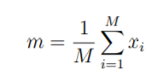

Figure 1result of the matlab code

Let, Wi be defined as mean centered image Wi = Xi – m

A covariance matrix is constructed as C = AAT

Where, A = [Φ1,Φ2,Φ3,..,ΦM] of size N2 x N2

1. **MATLAB CODE:**

data=imread('e:\Users\sush\Downloads\sush.jpg');

[r,c]=size(data);

Figure 2 the eigen values

m=mean(data')';

d=data-repmat(m,1,c);

co=d*d';

[eigvector,eigvl]=eig(co);

eigvalue = diag(eigvl);

[junk, index] = sort(eigvalue,'descend');

eigvalue = eigvalue(index);

eigvector = eigvector(:,index);

count1=0;

for i=1:size(eigvalue,1)

if(eigvalue(i)>0)

count1=count1+1;

end

end

vec=eigvector(:,1:count1);

x=vec'*d;

eigvalue

total=sum(eigvalue);

total

1. **RESULTS AND DISCUSSION:**

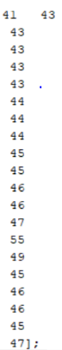Data:

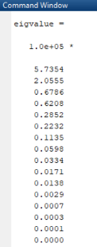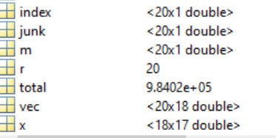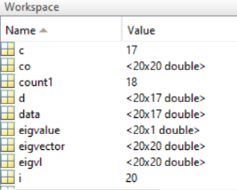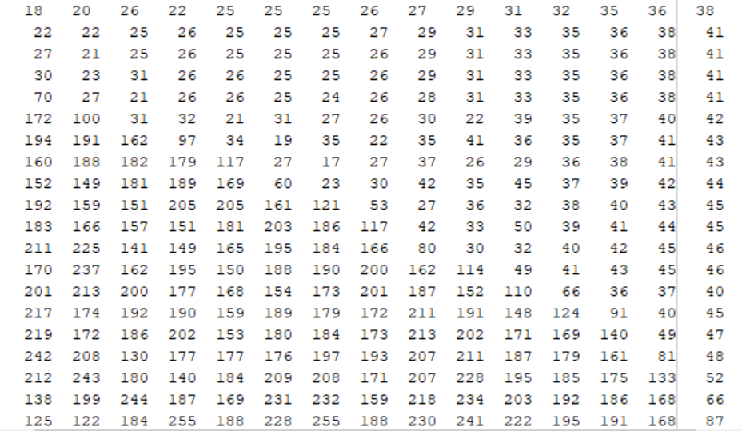

Figure 3data obtained from the image

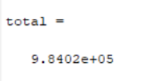

Compute the Propotion of variance for different k values:

O/P = sum (K number of eigen values )/ Total sum of the eigen values obtained

If K=2 , O/P= (EV1+EV2)/Total sum of the eigen values where EV1- eigen value 1 & EV2- eigen value2

|  |  |
| --- | --- |
| **K value** | **Propotion of variance** |
| 2 | 0.791 |
| 5 | 0.953 |
| 8 | 0.99 |
| 11 | 0.99 |

**Discussions:**

WE do not see much variation but the trend is that as the K value keeps on increasing the propotion of variance also increases and then becomes constant at a point and stabilizes.

The dimentionality reduces , the output of the pca analysis is the eigen values that we have obtained after the execution.

**CONCLUSION:**

In this paper we implemented the face recognition system using Principal Component Analysis and Eigenface approach. The system successfully reduced the dimensions for the analysis of the human faces and worked better in different conditions of face orientation.

In this research, Principal component analysis approach to the face recognition problem was studied and a face recognition system based on the eigenfaces approach was proposed. The algorithm has been tested for the image database and implemented using MATLAB. The algorithm developed in a generalized one which works well with any type of images. The tests conducted on PNG images and JPEG images of various subjects in different poses showed that this method gave very good classification of faces though it has limitations over the variations in size of image. The eigenface approach thus provides a practical solution that is well fitted to the problem of face recognition. It is fast, relatively simple and has been shown to work well in constrained environment.

**REFERENCES:**

[1] Face Recognition Machine Vision System Using Eigenfaces Fares Jalled, Moscow Institute of Physics & Technology, Department of Radio Engineering & Cybernetics, May 2017.

[2]Jure Leskovec, Mining of Massive datasets,section 11.1,page405

[3] [1] Hiremath, Vinay, and Ashwini Mayakar. ”Face recognition using Eigenface approach.” IDT workshop on interesting results in computer science and engineering, Sweden. 2009.

[4] Face Recognition using Principle Component Analysis Kyungnam Kim Department of Computer Science University of Maryland, College Park MD 20742, USA.

[5]online available : <https://blog.cordiner.net/2010/12/02/eigenfaces-face-recognition-matlab/>